AnswerBot- AI-powered FAQ and customer support automation.

Description
AnswerBot – AI-Powered FAQ and Customer Support Automation is an intelligent AI-based chatbot developed to automate frequently asked questions and customer support services. The system allows users to interact with the chatbot using natural language and receive quick, relevant, and accurate responses to their queries. It can provide information about products, services, general enquiries, troubleshooting steps, and other commonly requested details.
The main objective of AnswerBot is to reduce the workload of customer support teams by automatically handling repetitive and frequently asked questions. The chatbot provides instant responses and can be available 24/7, helping users receive support without waiting for a human representative. By using AI and natural language processing, the system can understand user queries and provide appropriate information in a simple and user-friendly manner.
This project improves customer experience by reducing response time, providing consistent information, and making support services more efficient. It can also help organizations save time and resources while maintaining better communication with their customers. The proposed system can be further enhanced with additional features such as multilingual support, personalized responses, knowledge-base integration, conversation history, and escalation to human support when required.

Scenario-Based Case Study

1. Background
- Many organizations receive a large number of customer queries every day.
- Most of these queries are repetitive and related to frequently asked questions.
- Customers expect quick responses and easy access to information.
- Traditional customer support methods require more time and human resources.
- To overcome these challenges, an AI-powered chatbot called AnswerBot is proposed.

2. Problem
- Customer support teams spend a lot of time answering repetitive questions.
- Customers may have to wait for a response during busy hours.
- Manual support can result in delayed responses and inconsistent information.
- Providing support outside working hours can be difficult.
- Handling a large number of customer queries at the same time becomes challenging.

3. Solution
- AnswerBot provides an AI-based automated solution for handling customer queries.
- The chatbot understands user questions using natural language processing.
- It provides relevant answers to frequently asked questions instantly.
- The system can provide information about products, services, troubleshooting, and general enquiries.
- Complex queries that cannot be handled by the chatbot can be transferred to human customer support.
- The system can be available 24/7 to provide continuous assistance.

4. Usage
- Customers can enter their questions through the chatbot interface.
- AnswerBot analyzes the user's query and identifies the required information.
- The chatbot searches the available knowledge base and provides a suitable response.
- Users can ask multiple questions during the same conversation.
- The system can be used by organizations for customer support, product enquiries, service information, and technical assistance.
- It can also be integrated into websites or other customer service platforms.

5. Outcome
- Reduces the workload of customer support employees.
- Provides faster responses to common customer queries.
- Improves the overall customer support experience.
- Reduces waiting time for users.
- Provides consistent and easily accessible information.
- Enables organizations to provide support continuously, including outside normal working hours.
- Helps save time and resources by automating repetitive support tasks.

1. Software Requirements
- Operating System: Windows 10/11, macOS, or Linux (supports cross-platform development and execution).
- Node.js (v18 or above): Runtime environment used to execute the backend server and application logic.
- npm (v9 or above): Package manager used to install and manage the required project dependencies.
- Express.js (v4/v5): Lightweight web framework used to build backend REST APIs and manage application routing.
- MongoDB / Mongoose ODM: NoSQL database used to store user information, chatbot data, FAQs, and other application records.
- Postman / ThunderClient: API testing tools used to verify requests, responses, and backend functionality.
- Code Editor: Visual Studio Code or a similar IDE used for coding, debugging, and project development.

2. Hardware Requirements
- Processor: Intel Core i5 (8th Gen or above) / AMD Ryzen 5 or equivalent for smooth application execution.
- RAM: 8 GB minimum (16 GB recommended for running the backend, database, and development tools simultaneously).
- Storage: Minimum 10 GB of available disk space for project files, dependencies, and database storage.
Epic-1: Project Architecture
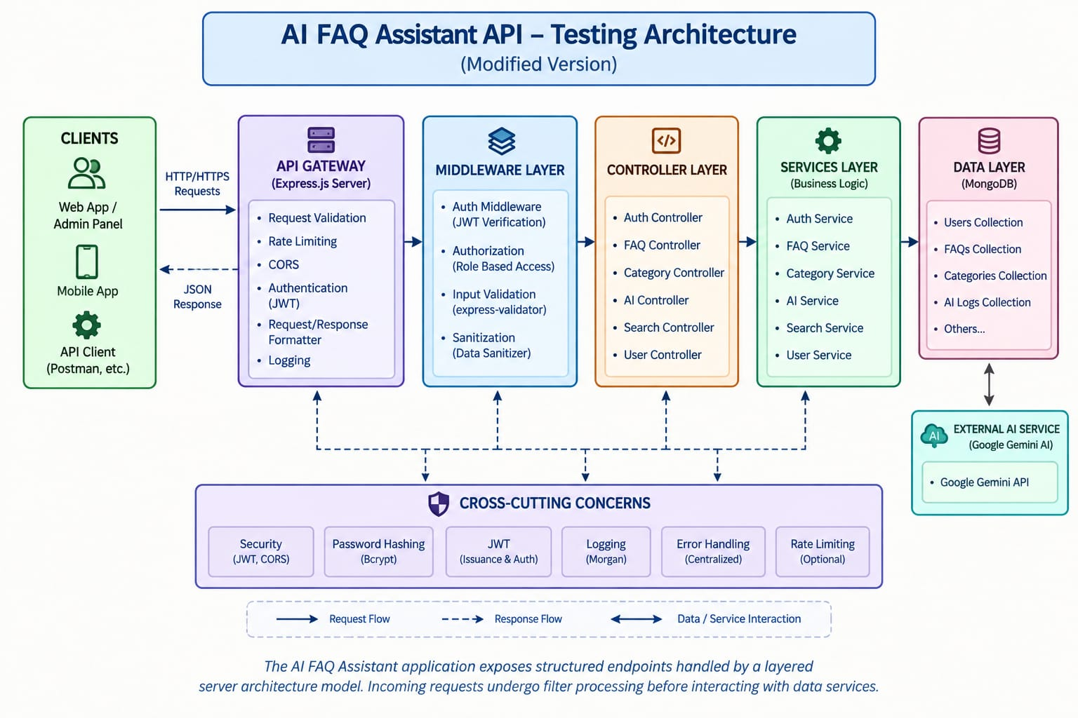
The AnswerBot application uses a layered server architecture to manage user requests, FAQ retrieval, customer support interactions, and AI-based response generation. Incoming requests pass through different processing layers before reaching the required services and database.

Components Definition
- Interface: API testing tools such as Postman or ThunderClient send requests to different API endpoints and receive responses in JSON format.
- Express Server Gateway: Handles incoming HTTP requests, manages API routes such as GET, POST, PUT, and DELETE, processes JSON data, and manages CORS configurations.
- Authentication Middleware: Validates user credentials or authentication tokens and controls access to protected resources.
- Granular Services (Logic Modules): Handles application-specific business logic such as user management, FAQ processing, customer queries, and chatbot response operations.
- Database Interface Layer: Mongoose acts as the interface between the application and MongoDB, allowing efficient storage, retrieval, and management of user and FAQ data.
- AI Flow (Service Integration): Integrates external AI services such as Google Gemini SDK to process user questions, generate relevant answers, and support automated FAQ and customer assistance workflows.

Entity-Relationship (ER) Diagram Description
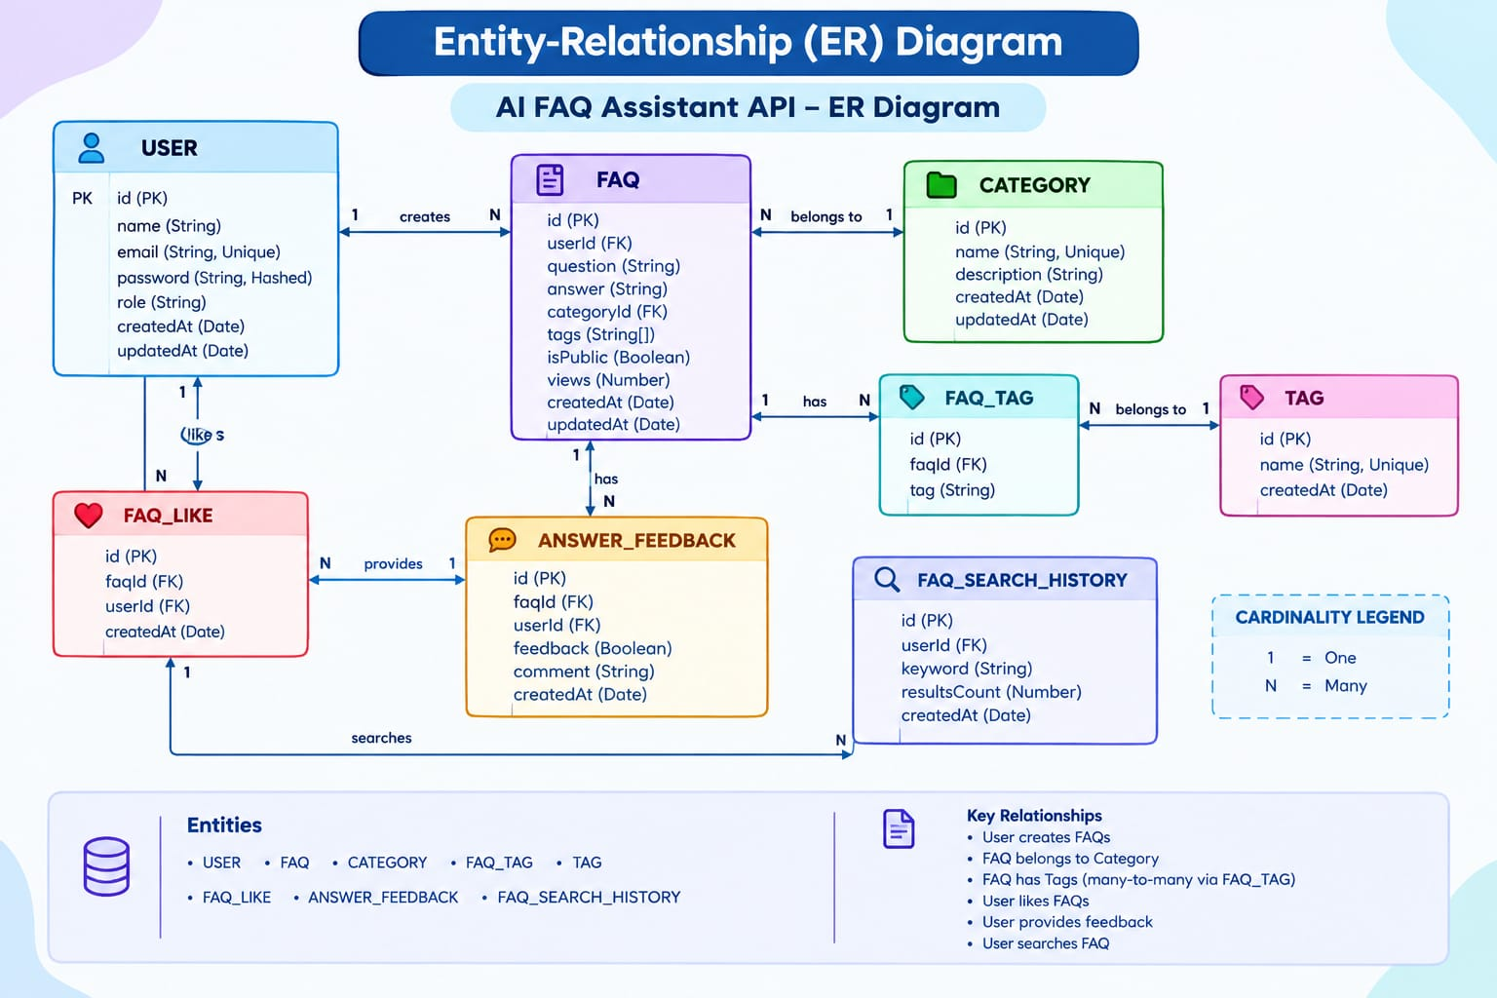
The AnswerBot backend database uses multiple MongoDB collections with logical relationships to manage user authentication, FAQ records, AI-generated responses, and category-based information in an organized manner.

1. User Entity
- _id (Primary Key - ObjectId)
- name (String, Required)
- email (String, Required, Unique)
- password (String, Hashed, Required)
- role (String, Default: "user")
- createdAt (Date, Automatically Generated)
- updatedAt (Date, Automatically Updated)

2. FAQ Entity
- _id (Primary Key - ObjectId)
- question (String, Required)
- answer (String, Required)
- category (String, Required)
- createdBy (Reference to User Collection)
- createdAt (Date, Automatically Generated)
- updatedAt (Date, Automatically Updated)

3. AI Generation Entity (Logical)
(AI-generated content is created dynamically through the integrated AI service before being stored.)
- topic (String)
- generatedQuestion (String)
- generatedAnswer (String)
- generatedCategory (String)
- generatedAt (Date, Automatically Genera

4. Category Entity (Logical)
- categoryName (String, Required)
- description (String)
- totalFAQs (Number, Automatically Updated)

Key Structural Mappings
User → FAQ (One-to-Many):
A registered user can create, update, and manage multiple FAQ records.
Category → FAQ (One-to-Many):
Each category can be associated with multiple FAQ documents based on the type of query.
User → AI Generated FAQ (One-to-Many):
A user can generate multiple AI-assisted FAQ entries, which can later be stored in the FAQ collection.
FAQ → Search Results (Logical Relationship):
User search requests retrieve relevant FAQ documents using keyword-based and intellige

Key Features

Key Features
- JWT Authentication & Authorization: Provides secure token-based authentication to protect private API endpoints from unauthorized access.
- AI FAQ Generation: Uses Google Gemini AI to automatically generate relevant questions, answers, and topic suggestions.
- Intelligent FAQ Search: Helps users quickly retrieve relevant FAQ information through keyword-based and intelligent search methods.
- Complete CRUD Operations: Supports Create, Read, Update, and Delete operations for managing FAQ records.
- Category Management: Organizes FAQs into structured categories for simple and efficient navigation.
- Password Encryption: User passwords are securely hashed using bcrypt before being stored in the database.
- Centralized Error Handling: Provides standardized API error responses for better reliability and easier debugging.
- Schema Validation: Mongoose validation maintains data accuracy and integrity before storing records.
- RESTful API Architecture: Modular Express.js routes provide organized and scalable backend services.
- MongoDB Integration: Uses MongoDB with Mongoose ODM for efficient NoSQL document storage and data management.

Roles and Responsibilities

Admin
- Manage and monitor all registered user accounts.
- View, update, and delete FAQ records when required.
- Review and monitor AI-generated content.
- Create and manage FAQ categories.
- Access and control all major system functionalities.

Content Creator
- Create and publish new FAQ records.
- Edit and manage their own FAQ content.
- Delete FAQs created by them.
- Generate questions and answers using AI assistance.
- Assign FAQs to appropriate categories.

Authenticated User
- View available FAQ information.
- Search FAQs using relevant keywords.
- Generate AI-assisted answers for queries.
- View and manage personal profile information.

Public User
- Access published FAQ information.
- Search available FAQs.
- Cannot create, modify, or delete FAQ records.
- Cannot access protected API endpoints or private user features.

User Flow

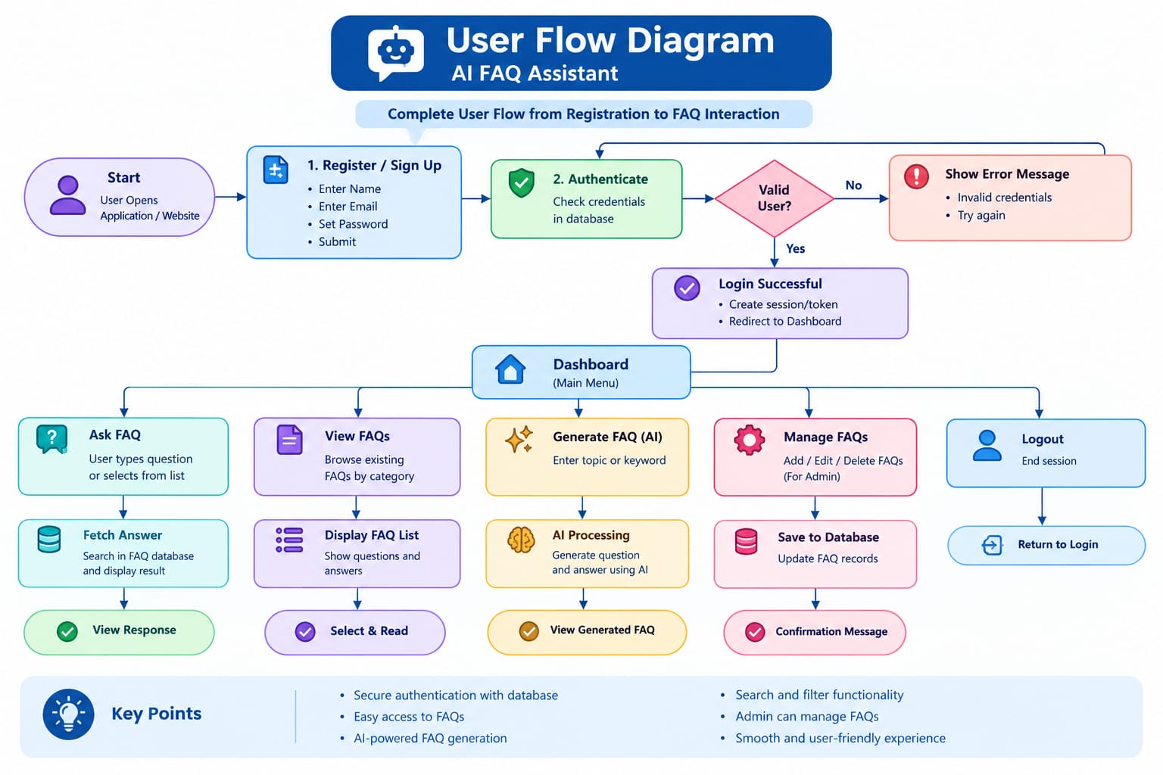
MVC Architecture Pattern
The AnswerBot system follows the Model-View-Controller (MVC) architecture pattern to organize application components into separate layers. This separation helps maintain a clear structure between data management, user interaction, and application logic, making the system easier to develop, maintain, and scale.

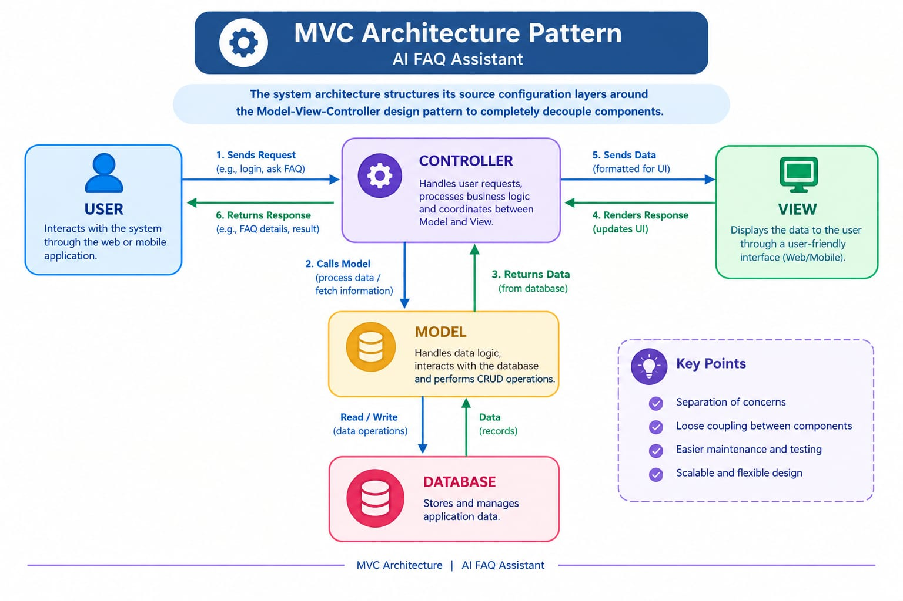
The AnswerBot system organizes its application layers using the Model-View-Controller (MVC) architecture pattern. This approach separates data handling, business logic, and API communication into independent components, making the application easier to maintain and extend.

Model Layer (Data Blueprint)
The Model Layer defines the structure of application data using Mongoose schemas. It specifies fields, data types, validation rules, and default values before records are stored in MongoDB. This layer manages database-related operations and maintains data consistency.

Controller Layer (Execution Matrix)
The Controller Layer acts as the main processing component of the application. It receives requests from API routes, validates the required input, processes the application logic, communicates with models or services, and returns the appropriate response in JSON format.

View Layer (Routing Network Interface)
Since AnswerBot is primarily a headless backend service, it does not use traditional UI template views. Instead, the API Routing Layer functions as the interface between client requests and controller logic.

Epic 2: Project Setup and Configuration

Creating Project Folder
- Create a new folder with the name AnswerBot.
- Inside the project folder, create a new subfolder named src to store the application source files.
- Open the AnswerBot project folder in Visual Studio Code for development and configuration.

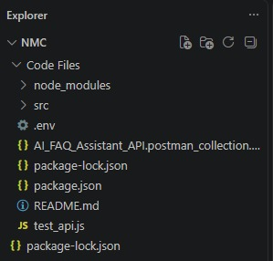

Server Setup (npm init)
Open the AnswerBot root folder terminal in VS Code and run the following commands:
npm init -y
npm install express mongoose dotenv cors jsonwebtoken bcrypt @google/genai
These packages are used for backend server development, MongoDB database connectivity, environment configuration, CORS handling, JWT authentication, password encryption, and AI integration.

File and Folder Structure Matrix
The project is organized into separate folders for controllers, models, routes, middleware, services, configuration, and other application resources. This modular structure makes the AnswerBot backend easier to develop, maintain, and manage.
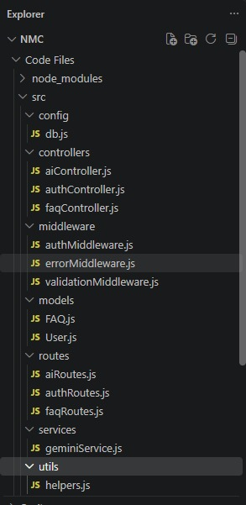

Epic 3: Backend Development

Core System Script Implementations

1. Gateway Server Node (src/server.js)
The server.js file acts as the main entry point of the AnswerBot backend application. It loads the required environment configurations, establishes the MongoDB database connection, initializes the Express server, and starts the application on the configured network port. It also enables essential middleware required for handling incoming API requests.
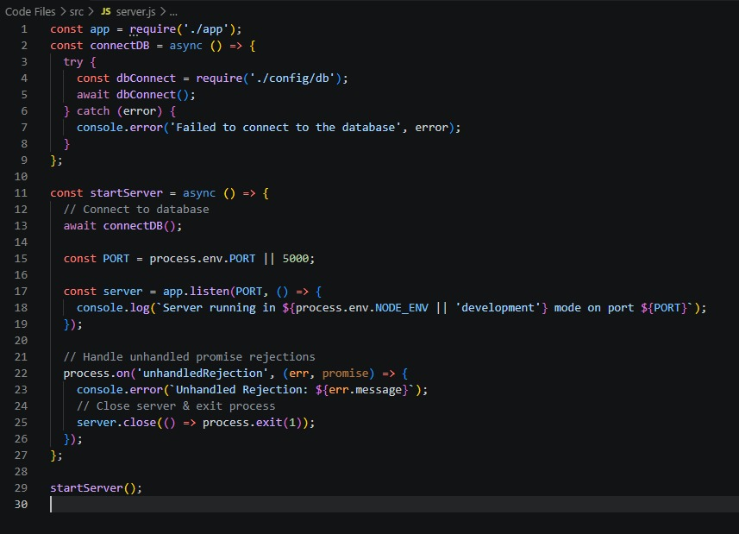
2. Gateway Express Setup (src/app.js)

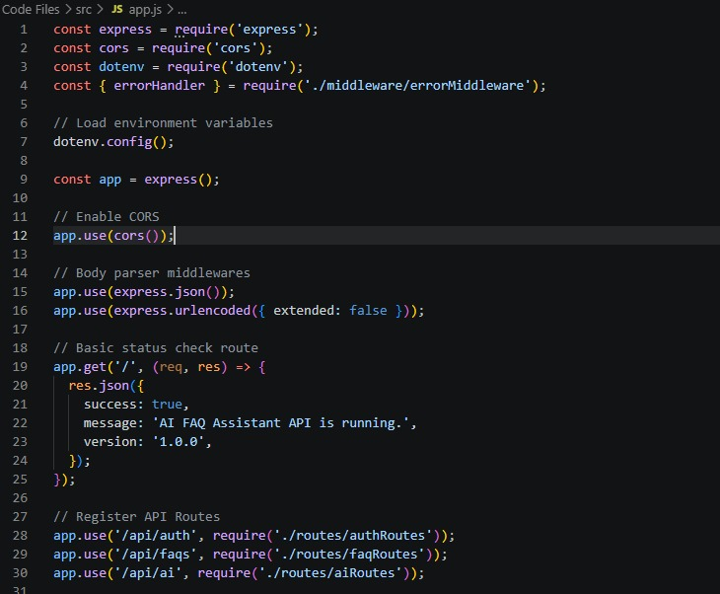

3. Security Access Middleware (src/middleware/authMiddleware.js)
The authMiddleware.js file handles authentication and access control for protected API endpoints. It intercepts incoming requests, extracts the JWT token from the authorization header, verifies the token, and validates the user's identity before allowing access to secured resources. Unauthorized or invalid requests are rejected with an appropriate error response.
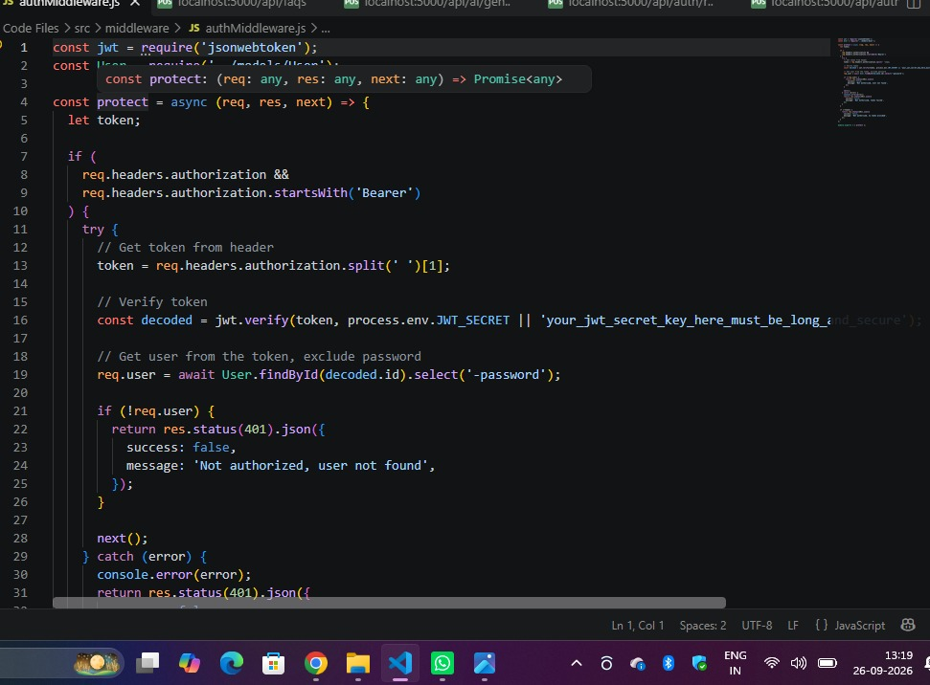
4. Centralized Error Handler Middleware (src/middleware/errorMiddleware.js)
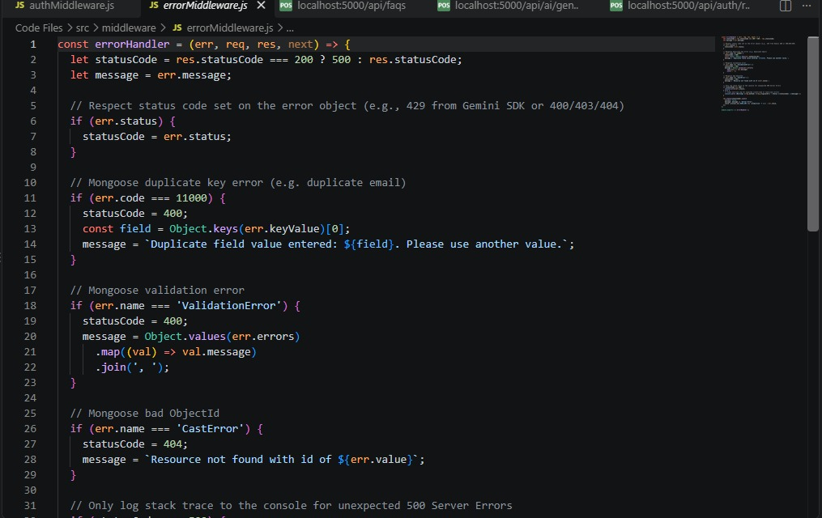

Epic 4: Database Configuration

Mongoose Schema Definitions

1. User Resource Document Schema (src/models/User.js)
Defines the structure and validation rules for user profile information. The schema validates required fields such as name, email, password, and role. It also supports secure password hashing before the user document is stored in the MongoDB database.
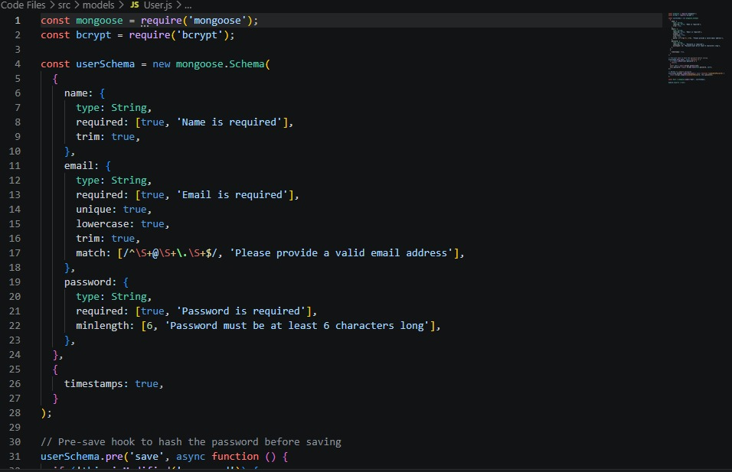

2. FAQ Resource Document Schema (src/models/FAQ.js)
Defines the main properties required for storing FAQ records, including question, answer, and category details. The schema also maintains a reference to the user who created the FAQ, helping to establish a relationship between the FAQ and User collections.

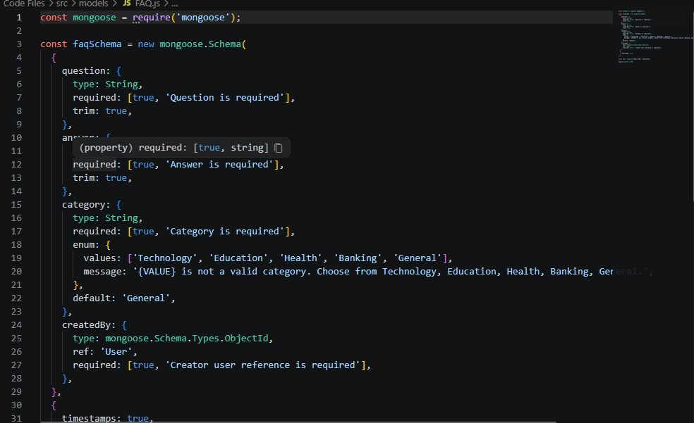

API Router Interface Endpoints

1. Public Authentication Operations (src/routes/authRoutes.js)
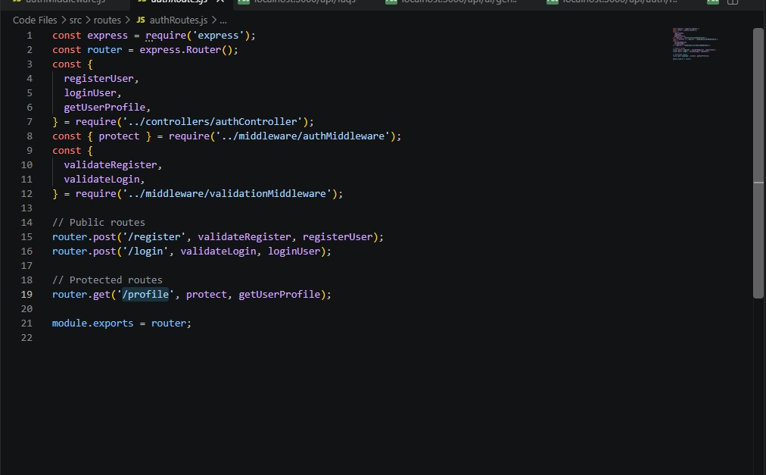

2. Protected FAQ Operations (src/routes/faqRoutes.js)
JavaScript

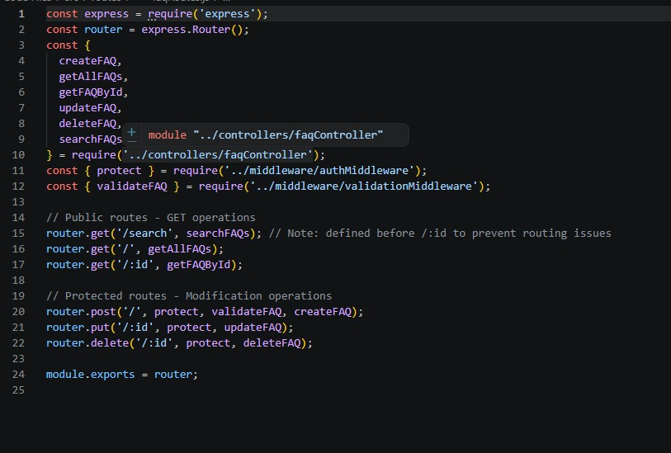

3. AI Automation Operations (src/routes/aiRoutes.js)
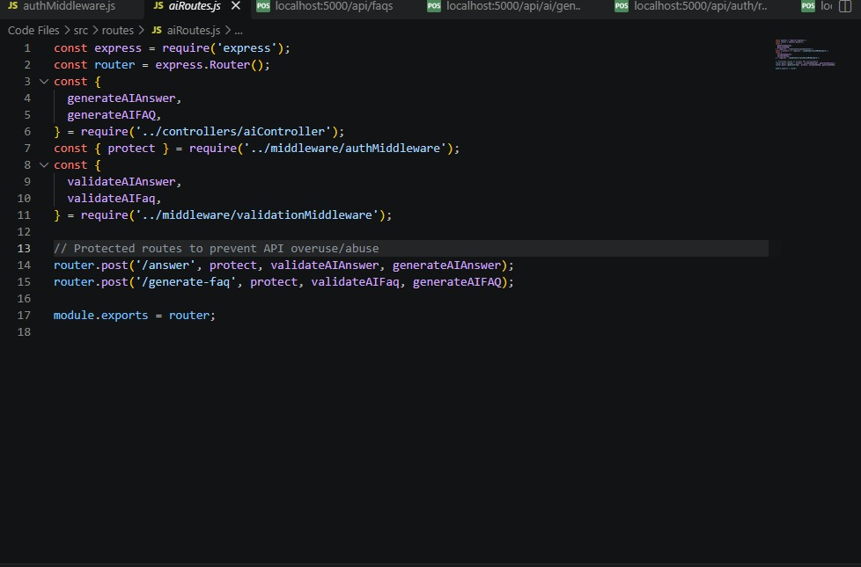

Epic 5: Project Execution

Running the API Application
- Install Postman or ThunderClient (VS Code extension) for testing and sending API requests.
- Start the AnswerBot backend development server using the configured environment parameters.
Bash
npm run dev

API Testing Specification Demo
To verify operational structural integrity via execution endpoints, map endpoints using the configurations below:

1. Identity Onboarding Path Registration
- Route: POST /api/auth/register
- Access: Public
- Payload Request Body JSON:

JSON

{
"name":"necky",
"email":"necky47@gmail.com",
"password":"neck36"
}

2. Profile Login Verification Quey

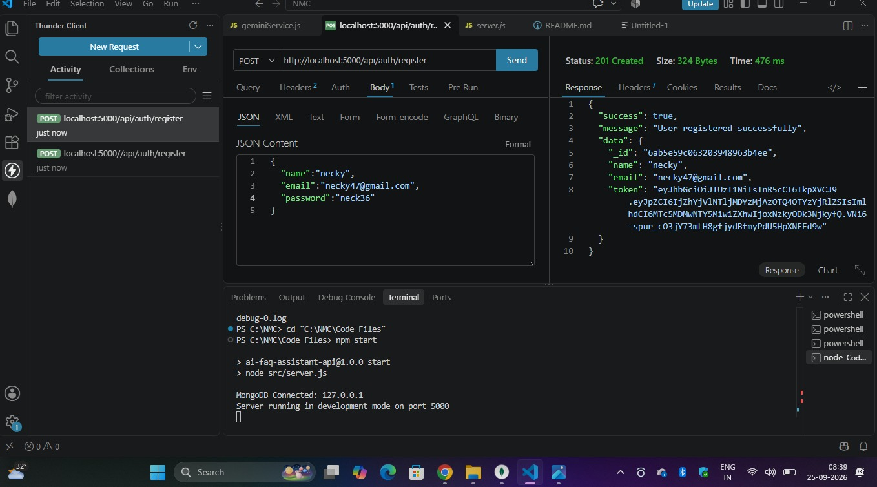
- Route: POST /api/auth/login
- Access: Public
- Payload Request Body JSON:
JSON
{
"email":div03@gmail.com,
"password":div321
}
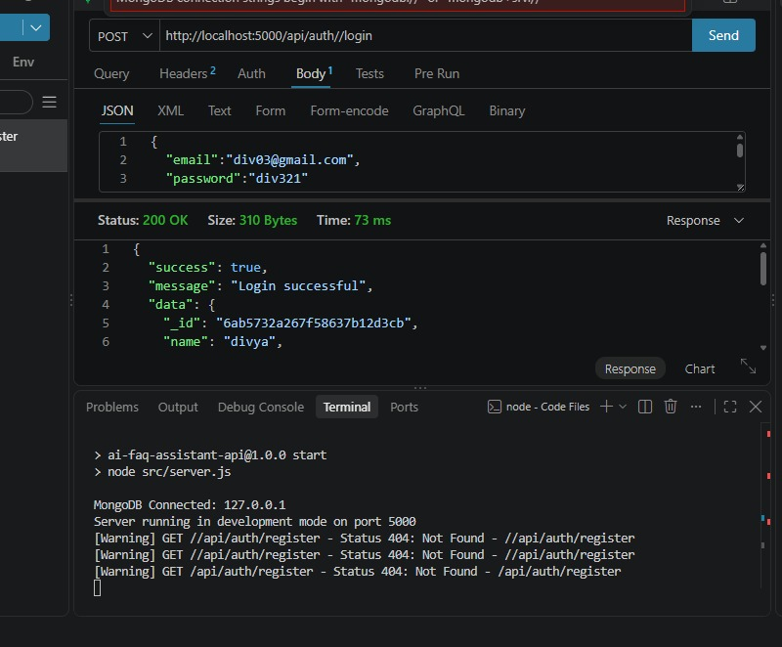

3. Resource Entity Creation (FAQ)
- Route: POST /api/faqs
- Access: Private (Bearer <JWT Token>)
- Payload Request Body JSON:
JSON

{
"question": "How do I configure custom category tags?",
"answer": "Navigate to settings panel, append keyword tags arrays, and save schema.",
"category": "Technology"

}
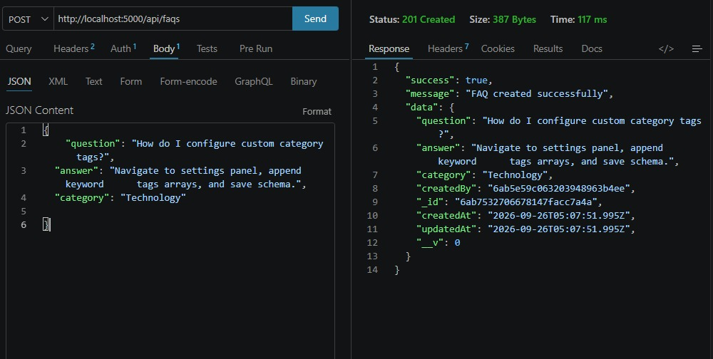

4. Keyword Resource Entity Fetching (Search)
- Route: GET /api/faqs/search?q=configure
- Access: Public

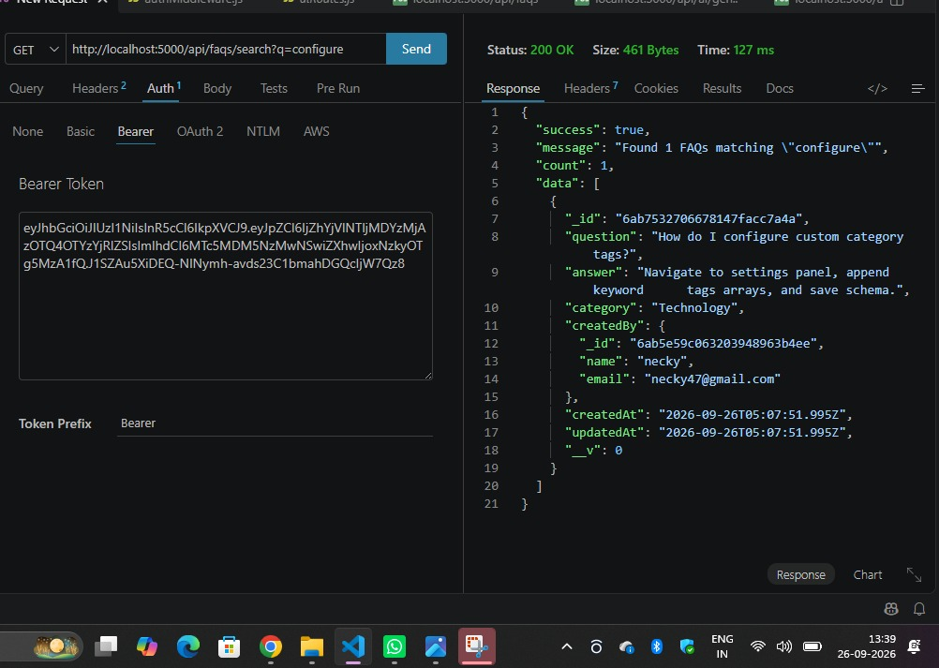

5. AI Intelligent Content Automation (Generate FAQ Pair)
- Route: POST /api/ai/generate-faq
- Access: Private (Bearer <JWT Token>)
- Payload Request Body JSON:
JSON

{
"topic": "Mongoose schema indexing validation runtime workflow optimization"
}

API TESTING VIDEO:
https://drive.google.com/file/d/1_TBzJZKZSFJGiQr_4sLfAwR3cUvNMkPV/view?usp=drivesdk
DEMO LINK:
https://drive.google.com/file/d/1RROlNrrazPyusmEqnb8wPS2K92DCJk2w/view?usp=drivesdk

